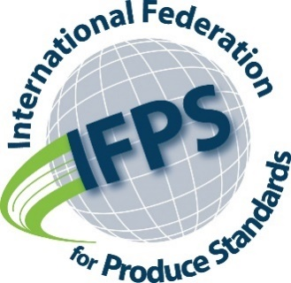
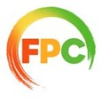
Invitation

Dear FPC Member
Our industry association is a member of IFPS, the International Federation for Produce Standards. IFPS already works on our behalf at a global level on product identification, food safety, traceability and information management standards.
With the growing importance of sustainability in all aspects of our industry value chains, and the almost inevitable emergence of increased numbers and intensity of rules, regulations, and standards, the IFPS Board of Directors has determined that our industry should consider how we can take a more proactive position in the sustainability space. We need to ensure that the requirements of a more structured sustainability regulatory framework, and supply chain reporting requirements, take the realities of our fresh produce value chains into consideration and that what we are being asked to do is feasible and adds value.
The IFPS Board would, therefore, like to invite you to attend a virtual global sustainability symposium on 10 November, 11am to 2:30pm Eastern Standard Time (EST) to 3.00pm to 7.30pm (GMT).
Once you have registered, you will receive an electronic copy of a discussion paper the IFPS Board had commissioned on the sustainability challenges for our industry. This paper will form the basis for the proceedings on 10 November.
IFPS is a member-led organisation and knows that its global presence has assisted all its member associations to be heard with greater clarity in global forums and standard setting efforts since its formation. In order to be equally as successful in the sustainability space in the future, IFPS is looking for your contribution to shape its direction.
Registration for the event can be done here:
https://cpmaacdfl.wufoo.com/forms/ifps-sustainability-symposium/

We are hoping that you will be able to join us.
Sincerely,
Nigel Jenney
CEO, Fresh Produce Consortium

